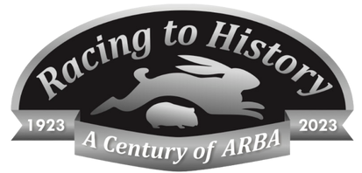
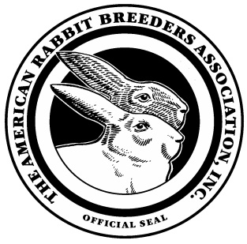
98th ARBA Convention & Show
ARTS & CRAFTS ENTRY FORM

First Name______________________ Last Name______________________________

Address_____________________________________________________________________________

City_________________________________ State________________ ZIP________________________

Telephone:(_______)___________________ Cellphone:(_______)____________________________

Email:_______________________________________________________________________________

THE CATERGORIES with media divisions:

Drawing—Chalk, Colored Pencil, Ink, Mixed, Pastel, Pencil, Other
Painting—Acrylic, Mixed media, Oil, Watercolor, Other
Printmaking—Engraving, Etching, Intaglio, Lithograph, Silk Screen, Wood, Block, Other
Sculpture—Ceramic, Glass, Metal, Mixed, Paper Mache, Plaster, Soap, Stone, Wood, Other
Woodworking
Photography—Black & White, Color, Other Computer
Generated Jewelry
Wearable Art
Stamping/Stencil/Folk Art
Ceramics/Pottery—Mold generated or applied to commercial product, Wheel thrown, Hand built
Needlework—Crocheting, Knitting, Cross-stitch, Quilting, Embroidery, Other

Category: ___________________________________ Division:_________________________________

Description of item:____________________________________________________________________

Will the item be for sale? Yes / No Price ____________

By signing you agree to follow all the rules for the Arts & Crafts competition as printed on pages 86-87 of the Convention Show Catalog.

Signature of Artist_____________________________________________

ENTRY INFORMATION
- Entry fee per item is Seven ($7.00).
- Postmark Deadline is September 25, 2023. No online entries.
- Craft entries are not to be included with regular rabbit/cavy entries.

Mail entries with payment before September 25 to:
Luke Vickrey
P.O. Box 451
Huntington, IN 46750

Checks payable to—Crossroads Rabbit & Cavy Shows

